Course Five

Regression Analysis: Simplifying Complex Data Relationships
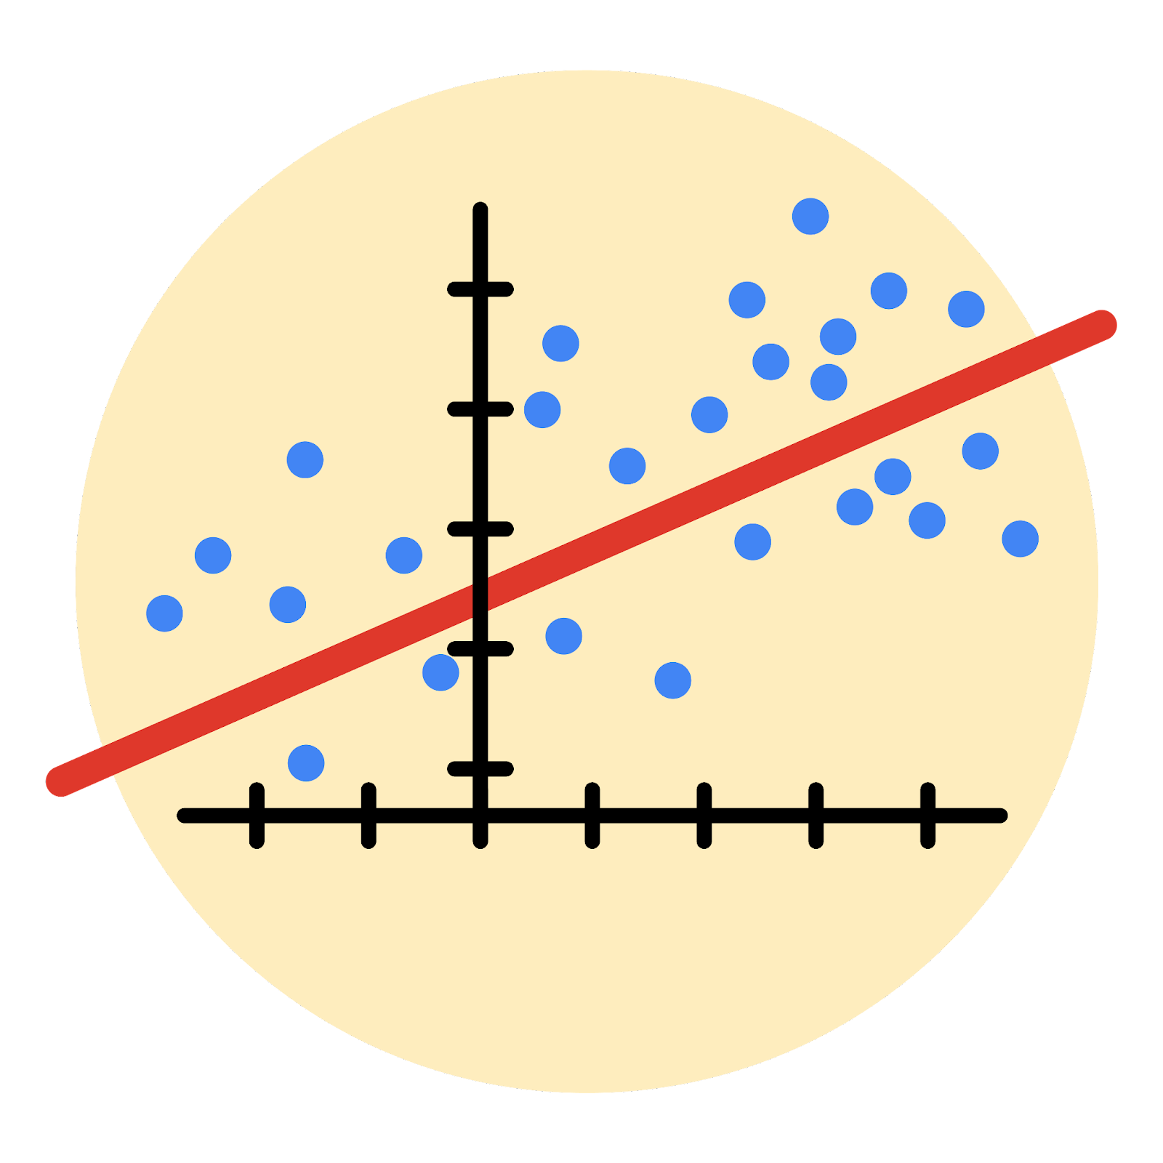

Instructions
Use this PACE strategy document to record decisions and reflections as you work through this end-of-course project. As a reminder, this document is a resource that you can reference in the future, and a guide to help you consider responses and reflections posed at various points throughout projects.

Course Project Recap
Regardless of which track you have chosen to complete, your goals for this project are:
- Complete the questions in the Course 5 PACE strategy document
- Answer the questions in the Jupyter notebook project file
- Build a multiple linear regression model
- Evaluate the model
- Create an executive summary for team members

Relevant Interview Questions
Completing the end-of-course project will empower you to respond to the following interview topics:
- Describe the steps you would take to run a regression-based analysis
- List and describe the critical assumptions of linear regression
- What is the primary difference between R² and adjusted R²?
- How do you interpret a Q-Q plot in a linear regression model?
- What is the bias-variance tradeoff? How does it relate to building a multiple linear regression model? Consider variable selection and adjusted R².
Reference Guide
This project has seven tasks; the visual below identifies how the stages of PACE are incorporated across those tasks.
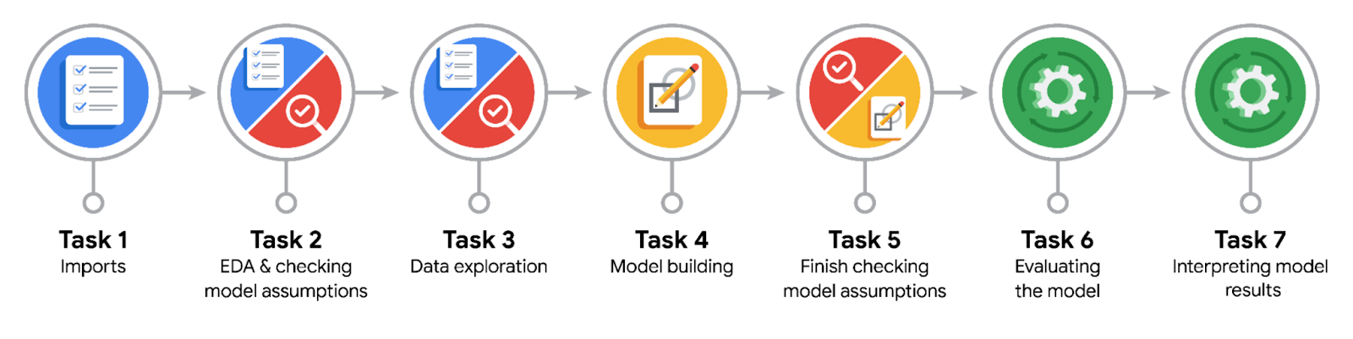
Data Project Questions & Considerations
PACE: Plan Stage
- Who are your external stakeholders for this project?
The project is asked by the Waze leadership team to predict churn rate to make decisions for better user retention as a wider plan to improve growth strategy.
It is currently followed by the operational manager and project manager.

- What are you trying to solve or accomplish?
The data team’s task is to make predictive models and interpret them to help the leadership come up with better strategies for user retention.

- What are your initial observations when you explore the data?
The data need to be clean and well-structured with no critical errors, outliers, or missing values in the first hand. Also more visualizations can help to identify initial insights and questions aligned with the project goal.

- What resources do you find yourself using as you complete this stage?
Project proposal, and communication with the director of the data team is ensured to stay perfectly aligned with the project goals.
PACE: Analyze Stage
- What are some purposes of EDA before constructing a multiple linear regression model?
Identifying outliers, missing values, identifying professional drivers and their corresponding churn rates, which are significantly different.

- Do you have any ethical considerations at this stage?
At this point, respecting the data and keeping it safe from bias is considered.

PACE: Construct Stage
- Do you notice anything odd?
The model’s Recall Score is so poor, which misses a lot of actual churns by misidentifying them as retention.
Also, despite the large correlation between `km_driven_per_day`, it has little to no effect on the churn in current logistic regression mode.

- Can you improve it? Is there anything you would change about the model?
The regression can be done on new or different sets of variables as several multicollinearity cases may decrease the power of the mode. Currently the model is very poor at identifying churns.

- What resources do you find yourself using as you complete this stage?
Sci-kit learn package as well as sns heatmap chart are helpful to identify correlation among independent variables, as well as validating the model.
PACE: Execute Stage
- What key insights emerged from your model(s)?
- What business recommendations do you propose based on the models built?
- To interpret model results, why is it important to interpret the beta coefficients?
- What potential recommendations would you make?
- Do you think your model could be improved? Why or why not? How?
- What business/organizational recommendations would you propose based on the models built?
- Given what you know about the data and the models you were using, what other questions could you address for the team?
- Do you have any ethical considerations at this stage?
Recall score (the rate of truly identifying a churn among all actual churns) is too poor: 7.5%. Other scores sound better, for instance, the model has a relatively good precision, that is to say if a model predicts a churn, with 54% rate, that would be an actual churn.
It would be a good direction to collect more features, which might provide better understanding of the churn.
They describe the rate of increase/decrease in the response variable by one unit increase in one specific independent variable.
Regarding ethical considerations, current data is studied with respect to all valid data, while also, they do not violate any privacy concerns. The data is interpreted by the most available tools, and no action is violating valid approaches to utilize the data.

